**Analysis of a Dataset for Bizops ( Oluwatobi Adebanwo )**

**Data source:** link here

**Database Schema:**

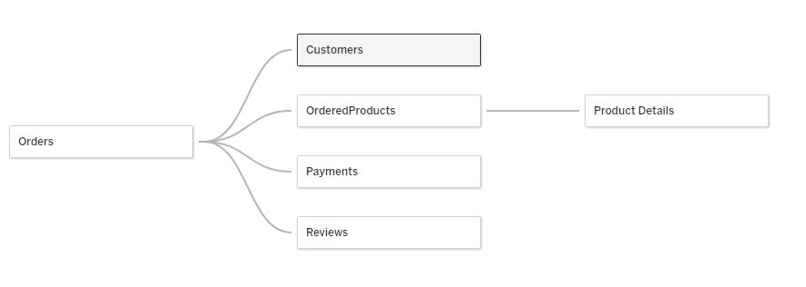

The dataset describes different product orders, timestamps, payments, reviews and customers data from Bizops for a period of less than 8 months (January to September 2018) across 27 states.

**Dataset Investigation Questions:**

* Which states should this business invest more marketing spend in?
* Which sellers, if any, should be delisted from this platform?

**Findings:**

The states in which the business should focus more marketing spend in include states with lowest revenue. Data was queried using Mysql.

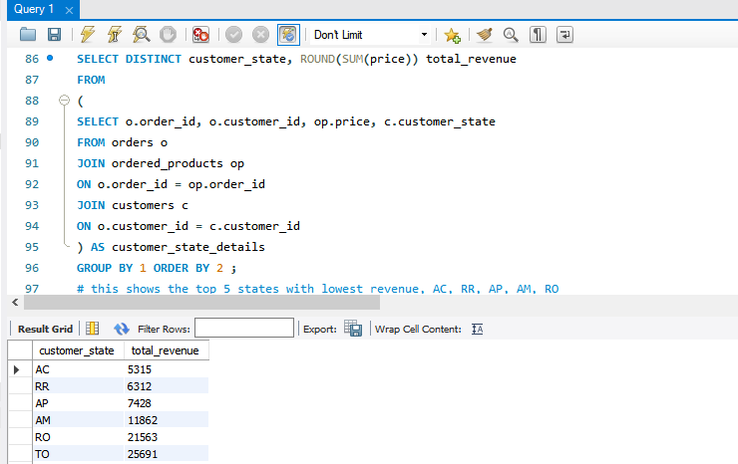

**This shows that more marketing spend in should be directed to states AC, RR, AP which have less than 10000 as revenue.**

**Findings 2**

Sellers that should be delisted from the platform should include sellers with lowest price, canceled orders and still part of the sellers having lowest review scores. The query below was used to draw this information

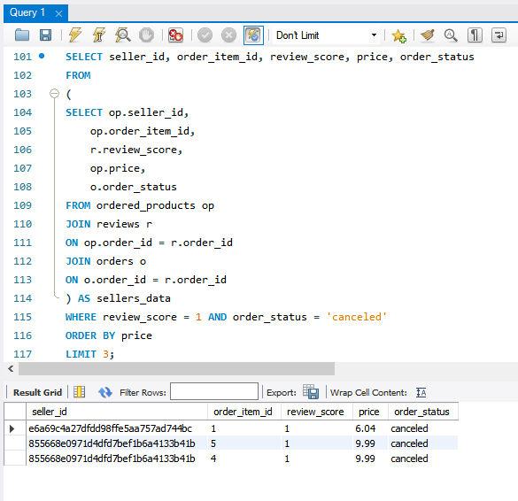

**The Image above shows seller_id that should be delisted from the platform**